TERMS & CONDITIONS
OUR GOAL IS TO ENSURE YOU STAY SAFE & HAVE FUN!
Let's get the boring stuff out the way so you can get back to it...
These terms and conditions apply to all bookings of Dubai Kartdrome/Dubai Autodrome experiences and supersede any earlier terms and conditions in relation to our experiences and no variation to these terms and conditions shall be binding unless agreed by Dubai
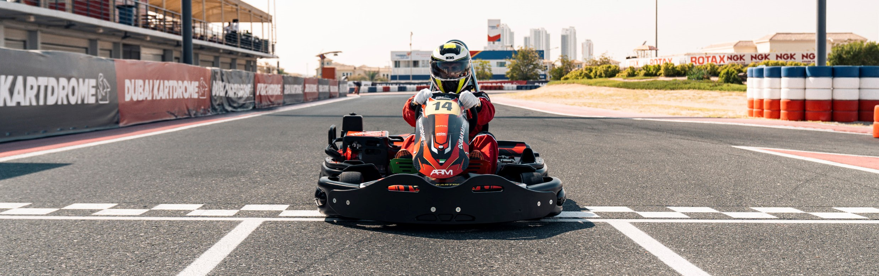
Autodrome in writing. By booking with the Dubai Autodrome, you agree on behalf of yourself and, if not yourself, the driver, to be bound by them in their entirety.
When using this website you must comply with these terms and conditions of use. We may change these terms and conditions from time to time so please read them each time you use the website to make sure you’re kept up-to-date. By continuing to use this website, you accept the current terms and conditions of use.

CONTENTS
- Minimum requirements for Kartdrome Outdoor and Indoor Venues
- Driving conduct - Rules and Driving Etiquette
- Conditions of Participation
- Cancellations and Refunds
- Promotions and Offers
- Additional Condition

MINIMUM REQUIREMENTS
What you need to know before booking or arriving at the Outdoor or Indoor Kartdrome venue
AGES AGES 7+ 13+
INDOOR KARTDROME OUTDOOR KARTDROME
Junior LR4/LR5 kart for ages 7 and Senior Sodi karts & CRG karts up Senior Sodi kart for ages 13 and up Minimum age: 13-years old
Juniors & Seniors run in different sessions

Should the kart be equipped with seatbelts these must be worn at all times | tied and tucked inside the  balaclava/helmet or fully inside the back of the race suit












Book Online before arriving bookings.dubaiautodrome.com
Minimum height of 1m 25cm
to drive the Junior Karts &
1
m57cm for Senior Karts
Race overalls,
face covering
helmets, and balaclavas
We have helmets, suits

and
balaclavas which are included in
the session fee
Disposable gloves are optional and will be charged on site.
Maximum weight
135
KG
Seat Belts
A full-face helmet must
be securely fastened and worn
during karting sessions
No MotoX, off-road or sky diving
or open face helmets permitted.
See additional conditions for more
helmet information
Wear closed shoes
Bring your own No sandals
allowed
Long hair must be
Signed Disclaimer
Drivers below the age of 18 years
old requires a Parent/Legal
Guardian to sign at registration
Driver’s must produce valid ID
when registering (Emirates ID,
Passport, Driving License)
Arrive-and-Drive sessions time 15-minute sessions
3 minutes of pace kart laps, with approximately 12 minutes driving on own

DRIVING CODE OF CONDUCT
OUR ACTIVITIES CAN BE INTIMIDATING FOR ANYONE. TO KEEP OUR GUESTS SAFE WE FOLLOW OUR A STRICT CODE OF CONDUCT TO ENSURE YOU STAY SAFE AND HAVE THE MOST FUN POSSIBLE:
- No bumping.
- No short cuts.
- No driving the wrong direction.
- Long hair must be tied and tucked into the balaclava or helmet or fully inside the race suit and tightly secured.
- Not for pregnant women, or those with existing medical conditions.
- No carrying mobile phones when driving on track.
- Slow down and drive at walking pace in the pitlane.
- Should the karts be equipped with seat belts it’s mandatory that they are worn at all times.
- Helmets will be provided by Dubai Kartdrome. It is the responsibility of the customer to ensure that the correct size helmet is chosen, the helmet fits securely and is fastened throughout the driving experience.

CONDITIONS OF PARTICIPATION
DUBAI KARTDROME IS HERE FOR YOUR ENJOYMENT, HOWEVER OUR POLICIES AND CONDITIONS WILL BE IMPLEMENTED TO KEEP OUR GUESTS AND STAFF SAFE AT ALL TIMES.
BY TAKING PART IN ANY ACTIVITY AT DUBAI KARTDROME, YOU AS A DRIVER, SPECTATOR OR LEGAL GUARDIAN AGREE TO:
- Sign the Dubai Autodrome disclaimer - drivers below the age of 18 require a parent/ legal guardian to sign at registration.
- Observe all circuit/track rules and regulations and all instructions given by Dubai Autodrome, including our Kartdrome coordinators.
- Observe and comply with any advice, instruction, request, restriction or decision made by us whether on the grounds of the safety of the driver or any other person or for any other reason at all.
- That Dubai Kartdrome’s opinion on all matters regarding safety will be final.
- That any driver acting in a manner which, in our opinion, is dangerous or may interfere with or disrupt the experience, we will at our sole discretion and without further liability to us immediately have the experience terminated without refund. Restrictions on drivers based on conduct to be enforced at the discretion of the management, regardless of bookings made in advance.
- The driver must not have consumed any alcohol prior to the experience and we will be entitled at the time for any experience to prevent a driver from driving who, in our opinion, may have consumed alcohol beforehand.
- When required by Dubai Autodrome all drivers, without exception, must wear their own or the provided crash helmet, race suit and suitable sports shoes, gloves are optional for racers. Sandals are not allowed. Should the kart be equipped with seatbelts it is mandatory to wear them.
- Attend the full safety briefing before taking part in the driving experience.
- Dubai Autodrome Management is not responsible for the theft or loss of personal property. Please ensure your belongings are not left unattended.

PRICING, CANCELLATIONS & REFUNDS
- Karting sessions can be booked online dubaiautodrome.ae or purchased on-site. Karting sessions purchased on-site (at reception) are subject to availability and available on a first-come, first-serve basis.
- We reserve the right to cancel an experience due to adverse weather conditions that may affect your safety. We cannot be held liable for any costs incurred in this circumstance. You will be entitled to use an alternative experience session no more than three months after the initial cancelled experience.
- No refunds, cancellations or re-scheduling will be provided for online or over-thecounter bookings once made.
- No refunds, credits or re-scheduling will be provided for guests not arriving on the correct day or time of the booking.
- No refunds will be provided in the event of a timing system error which may result in faulty or incorrect lap times.
- Dubai Kartdrome reserve the right to cancel an activity due to any governmental directive provided. Dubai Kartdrome cannot be held liable for any costs incurred in this circumstance.

PROMOTIONS AND OFFERS
- All promotions, best deals, happy hours and offers by Dubai Autodrome or any third-party cannot be used in conjunction with any other offer, promotion or best deal.
- Dubai Kartdrome cannot be held responsible for the prizes, products or services offered to users through the third-party vendors.
- Entertainer/Groupon offers cannot be booked in advanced using online bookings.
- Promotions, offers, prizes or vouchers cannot be exchanged for cash.
- Dubai Kartdrome reserves the right to stop any promotion, offer or deal without notice. Not valid during public holidays or school breaks.

ADDITIONAL CONDITIONS
- An AED 15 annual registration and renewal fee chargeable to all participants must be paid on-site.
- Customers are responsible for ensuring they select the correct time and date for their session.
- R-MAX Requirements
•At least 10 Arrive and Drive karting session or able to do 1.15.00 lap time at the Outdoor Circuit or have a valid karting race license.
•RMAX: Minimum 16-years old
- 2-seater Requirements:
•Driver: minimum 18-years
•Passenger: Must fit safely and securely into the seat
- Bambino Cup drivers must be at least 5 years old to race or practice (ID Required).
- IAME Cadet/Rotax Micro drivers must be at least 8 years old to practice or race, unless the driver has a history of having completed six events (SWS or Dubai Bambino Cup) then 7.5 years old to practice is acceptable (ID Required).
- Driver Height: Minimum height of 1.57m, to drive the Senior Sodi & CRG Karts
- Dubai Kartdrome offers helmets and suits available in a range of sizes from XXXSmall to XX-Large. If a driver is unable to safely wear the provided protective equipment due to sizing issues, entry may be denied at our discretion. In such cases, a full refund will be issued.
- Lost or damaged Car Park tickets are subject to an AED 250 daily charge.
- Kart Owners are not permitted to part their trailers/vans/trucks overnight.
- To support our sustainability initiatives, all race results will be sent to the email registered on RaceFacer. Alternatively, you can download the RaceFacer App to see your results.

ADDITIONAL CONDITIONS CONTINUED
For guests who bring their own helmet
Helmets are the most important piece of equipment to help keep you safe. We therefore follow strict international guidelines to ensure the helmet you bring conforms to the minimum safety standards.
All kart owner & rental clients who wish to use their own helmets, must ensure that their Helmets meet ECER 22.05 as a minimum standard before entering the circuit. It is your responsiblity to ensure that your helmet is the correct size and fastened securely at all times.
Other standards which are accepted:
British Standard BS 6658:1985 and carry the BSI Kitemark (UNECE Regulation 22.05) or a European Economic Area member standard offering at least the same safety and protection as BS 6658:1985, and carry a mark equivalent to the BSI Kitemark or
FIA 8860-2018 (with FIA hologram) or FIA 8860-2010 or FIA 8860-2004 NOT
VALID AFTER 31.12.2020 FIA 8859-2015 Snell SA 2010 + FIA 8858-2002 NOT VALID AFTER 31.12.2023 + Snell SA 2010 or SAH2010 + FIA 8858-2010 or bearing a CIK certification.
For more information, please visit www.dubaiautodrome.ae or contact us on
+9714 806 2220 info@dubaiautodrome.com

